**Simon Crawford-Phillips**

Conductor/Director/Pianist

*“The conductor Simon Crawford-Phillips proved to be an enthralling figure both as a musician and a stage persona… energetic, fast, constantly and thrillingly on the front foot.”* (Västmanlands Tidning).

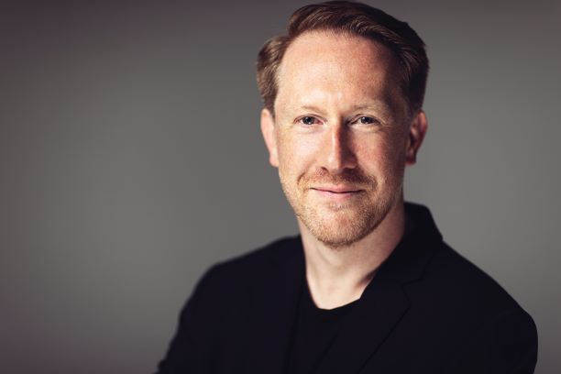Simon Crawford-Phillips has built a unique career as a conductor, pianist and creative programmer.

He has held positions as Chief Conductor of Västerås Sinfonietta (2016-2028) and Conducting Fellow of the NDR Elbphilharmonie and in 2023 made a critically acclaimed debut with the Stockholm Royal Opera conducting Britten’s *A Midsummer Night’s Dream*. In 2025 Simon was made Artistic Director of the Swedish National Orchestral Academy (SNOA) at Gothenburg University. Simon’s revealing and eclectic programming is reflected in an extraordinarily varied career and a passion for championing contemporary and undiscovered repertoire.

Simon’s chamber ensembles include The Nash Ensemble (he is Co-Artistic Director alongside Adrian Brendal), The Kungsbacka Piano Trio and Stockholm Syndrome Ensemble. He is the Artistic Director of the Change Music Festival in Sweden, Co-Artistic Director of the Wye Valley Chamber Music Festival and directed his own series ‘Musikaliska Möten’ at the unique ‘Musikaliska Kvarteret‘ – Stockholm’s oldest concert hall!

Simon regularly collaborates with artists such as Daniel Hope, Torleif Thedéen, Lawrence Power, Roderick Williams, Carolyn Sampson, Pekka Kuusisto, Colin Currie, Konstantin Krimmel, Andrew Staples and Malin Broman in repertoire from Haydn and Schumann to Adès, Byström, Dean and Reich. This season Simon has also curated a chamber series for BBC Radio 3 at LSO St Luke’s.

Upcoming conducting debuts include orchestras such as the BBC National Orchestra of Wales for a new commission with Lawrence Power, Norrlands Opera and Oulu Symphony as well as return invites to Stockholm Radio, Royal Stockholm Philharmonic, Swedish Royal Opera (for a new production of Gustavio), Norrköping and Gävle Symphonies amongst others. Simon has broadened the Västerås Sinfonietta’s reach and repertoire which now includes a Mendelssohn Symphony album cycle due for completion in 2026.

Simon’s debut with the Swedish Royal Opera in Britten’s *A Midsummer Night’s Dream,* was a notable success, the Svenska Dagbladet wrote “*The Swedish Royal Opera Orchestra under the direction of Simon Crawford-Phillips manage to reveal the myriad of temperament and structure that the music contains, without the dreaminess disappearing*”.

Recent conducting engagements have included Helsinki Philharmonic for the Finnish premiere of Sandström’s Cello Concerto with Torleif Thedéen, a double visit to Scottish Chamber Orchestra (one in a shared programme with Pekka Kuusisto), Neubrandenburg Philharmonic Orchestra, Swedish Chamber Orchestra, Gothenburg Symphony, Uppsala Kammarorkester, Nordic Chamber, Helsingborg Symfoniorkester, Dalasinfoniettan and Sinfonia Varsovia for Warsaw’s Lutosławski Chain Festival. He also made his debut with the Zurich Chamber Orchestra for an extensive European tour alongside Daniel Hope, and has assisted Daniel Harding, Alain Altinoglu and Stanislav Kochanovsky at the Verbier Festival.

World premieres have included conducting Börtz’s Violin ‘Concerto for One’ with Malin Broman and Norrköpings Symfoniorkester, Djuro Zivkovic’s violin concerto with Pekka Kuusisto and the Swedish Chamber Orchestra, and the world premiere of a new double concerto with Tapiola Sinfonietta from Finnish composer Sauli Zinovjev written for Simon and Hugo Ticciati. Simon values every opportunity to collaborate directly with composers and has been fortunate to work alongside Britta Byström, Sofia Gubaidulina, Simon Holt, Colin Matthews, Steve Reich, Mark-Anthony Turnage and Huw Watkins.

As a pianist, The Guardian says Simon has “*profound sensitivity and technical brilliance, achieving an* *expressive intensity that makes for compelling listening.”* Simon has a long-standing duo partnership with Philip Moore and performs in premiere festivals and concert halls across Europe including Verbier, Schleswig-Holstein, Edinburgh, Gstaad and at Wigmore Hall. Notable concerto debuts include the NHK Symphony Orchestra under the baton of Alan Gilbert, BBC Scottish Symphony Orchestra under Ilan Volkov and the Swedish Radio Symphony Orchestra directing from the keyboard.

As a prolific recording artist, Simon has recorded for Alba, BIS, Channel Classics, DG, Deux-Elles, Harmonia Mundi, Hyperion, LSO Live, Naxos, Nonesuch, Onyx, Signum Classics, Alba and DB Productions. In addition to radio and television broadcasts in Europe, Australia and Japan Simon has also presented concerts for Sweden’s classical music radio station P2.

Simon is a Professor at the Edsberg Institute, Stockholm Royal Academy of Music and at the Academy of Music and Opera at Mälardalen University. Guest teaching has included the Royal Academy of Music, Guildhall School of Music and Drama, at Indiana University in Bloomington, the University of Colorado and for Accordi Musicali in Pescara.

Simon was elected a Fellow of the Royal Academy of Music in 2010 and is a Steinway Artist. Simon Crawford-Phillips is managed worldwide by Percius [www.percius.co.uk](http://www.percius.co.uk).

This biography is valid for use until September 2026.

We update our biographies regularly. For the most up-to-date version please email [info@percius.co.uk](mailto:hannah@percius.co.uk)