Rachel Podger
Baroque Violin/Director

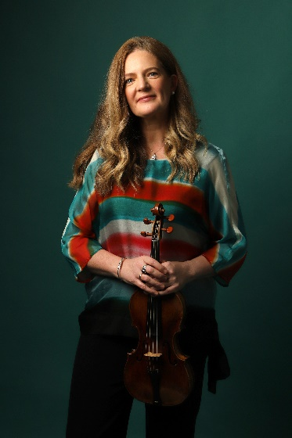
“Rachel Podger, the unsurpassed British glory of the baroque violin,” (The Times) has established herself as a leading interpreter of the Baroque and Classical. She was the first woman to be awarded the prestigious Royal Academy of Music/Kohn Foundation Bach Prize in October 2015, was Gramophone Artist of the Year 2018, and the Ambassador for REMA’s Early Music Day 2020. A creative programmer, Rachel is the founder and Artistic Director of Brecon Baroque Festival and her ensemble Brecon Baroque; is Principal Guest Director for Tafelmusik; Patron for The Continuo Foundation and an Ambassador for the Learned Society of Wales. Rachel was awarded BBC Music Magazine Recording of the Year and Instrumental Award 2023 for her solo album Tutta Sola.

Rachel continues to broaden her relationships with orchestras, ensembles and venues worldwide. Recent highlights are her inaugural performance with Tafelmusik as Principal Guest Director and a tour of Asia, her debut directing Scottish Chamber Orchestra, and a long-awaited return to the Netherlands Bach Society. Upcoming performances include her debut with Bavarian Radio Symphony, a return to Scottish Chamber Orchestra, a US/Canadian tour with Tafelmusik, and tours of Duologue with Lucie Horsch, ‘Just Biber’ (Biber 1681 Sonatas) and The Muses Restor’d with her ensemble Brecon Baroque.

As a soloist and chamber musician, recent collaborations have included the Austrian premiere of A Guardian Angel with VOCES8 at Vienna Konserthaus, a tour of Angels and Demons with I Fagiolini, a Vivaldi tour with Arte dei Suonatori, Bach Goldberg Variations Reimagined and Vivaldi Four Seasons with Brecon Baroque.

Recent album releases on Channel Classics include Just Biber, The Muses Restor’d with Brecon Baroque which was awarded a Gramophone Editor’s Choice, BBC Music Magazine double 5* review & Chamber Choice and a Diapason d’Or, and the world premiere recording of Bach Goldberg Variations Reimagined in a new chamber arrangement by Chad Kelly with Brecon Baroque. Upcoming recording plans include a disc of Duologue with Lucie Horsch.

A dedicated educator and inspirational coach, Rachel has begun her own training programme BOGA (Bow Yoga), she holds the Micaela Comberti Chair for Baroque Violin at the Royal Academy of Music and the Jane Hodge Foundation International Chair in Baroque Violin at the Royal Welsh College of Music and Drama. Rachel also has a regular relationship with The Juilliard School in New York. Rachel Podger is managed worldwide by Percius. www.percius.co.uk

This biography is valid for use until August 2026.
We update our biographies regularly. For the most up-to-date version please email info@percius.co.uk

