Rachel Podger
Baroque Violin/Director

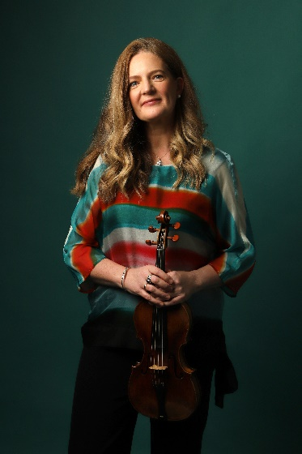
“Rachel Podger, the unsurpassed British glory of the baroque violin,” (The Times) has established herself as a leading interpreter of the Baroque and Classical. She was the first woman to be awarded the prestigious Royal Academy of Music/Kohn Foundation Bach Prize in October 2015, was Gramophone Artist of the Year 2018, and the Ambassador for REMA’s Early Music Day 2020. A creative programmer, Rachel is the founder and Artistic Director of Brecon Baroque Festival and her ensemble Brecon Baroque; is Principal Guest Director for Tafelmusik; Patron for The Continuo Foundation and an Ambassador for the Learned Society of Wales. Rachel was awarded BBC Music Magazine Recording of the Year and Instrumental Award 2023 for her solo album Tutta Sola.

Rachel continues to broaden her relationships with orchestras, ensembles and venues worldwide. Recent highlights are her inaugural performance with Tafelmusik as Principal Guest Director and a tour of Asia, her debut directing Scottish Chamber Orchestra, and a long-awaited return to the Netherlands Bach Society. Upcoming performances include her debut directing Bavarian Radio Symphony, a return to Scottish Chamber Orchestra, a US/Canadian tour with Tafelmusik, and tours of Duologue with Lucie Horsch, ‘Just Biber’ (Biber 1681 Sonatas) and The Muses Restor’d with her ensemble Brecon Baroque.

As a soloist and chamber musician, recent collaborations have included the Austrian premiere of A Guardian Angel with VOCES8 at Vienna Konserthaus, a tour of Angels and Demons with I Fagiolini, a Vivaldi tour with Arte dei Suonatori, Bach Goldberg Variations Reimagined and Vivaldi Four Seasons with Brecon Baroque.

Rachel has also collaborated with many artists including Robert Levin, Jordi Savall, Christopher Glynn, Kristian Bezuidenhout, Masaaki Suzuki, Philharmonia Baroque, Orchestra of the Age Enlightenment, Handel and Haydn Society, San Francisco Early Music, Holland Baroque Society, and Oregon Bach Festival.

Recent album releases on Channel Classics include Just Biber which received a 5* review in The Times “pairing her dynamic fiddling with equally colourful playing from members of Brecon Baroque … the most imaginative and inviting with a particular teasing charm and extra spurt of flair.”; The Muses Restor’d with Brecon Baroque which was awarded a Gramophone Editor’s Choice, BBC Music Magazine double 5* review & Chamber Choice and a Diapason d’Or, and the world premiere recording of Bach Goldberg Variations Reimagined in a new chamber arrangement by Chad Kelly with Brecon Baroque (The Guardian: Podger is a supreme baroque player, and this is a bold and different way to think about Bach’s unfathomable genius). Upcoming recording plans include a disc of Duologue with Lucie Horsch.

Previous award-winning releases include the world premiere of three previously unfinished Mozart sonatas and Beethoven Sonatas 1, 5, and 10, both with Christopher Glynn: “This selection stands out for its individuality and a characteristic refusal to take the music at face value." (Gramophone); a 7CD boxset of her award-winning Vivaldi concertos (which Classic FM named as their ‘Album of the Week’) and an album of C.P.E. Bach, with duo partner Kristian Bezuidenhout, which BBC Music Magazine gave a double five star rating - "Their music-making is infectiously spontaneous yet tellingly 'considered' - seamless rapport and impeccably-judged articulation delighting in a stream of illuminating felicities"; Vivaldi Le Quattro Stagioni with Brecon Baroque and Bach Cello Suites transposed for the violin, which according to BBC Music Magazine, the five-star album is “a spellbinding set that is arguably Podger's finest recorded achievement to date…one would naturally assume the suites were violin originals after experiencing her life-enhancing playing." Numerous awards have included two Baroque Instrumental Gramophone Awards for La Stravaganza (2003) and Biber Rosary Sonatas (2016), Opus Klassik for Tutta Sola, the Diapason d’Or de l’année in the Baroque Ensemble category for her recording of the La Cetra Vivaldi concertos (2012), two BBC Music Magazine awards in the instrumental category for Guardian Angel (2014) and the concerto category for the complete Vivaldi L’Estro Armonico concertos (2016).

Rachel is a sought-after classical music media personality, appearing on and presenting/performing for many significant media platforms around the world including BBC Radio 3, The Proms, Classic FM, Scala Radio, Apple Music, ABC Classics, Radio France, WDR, CNC, CBC and many more.

A dedicated educator and inspirational coach, Rachel has begun her own training programme BOGA (Bow Yoga), she holds the Micaela Comberti Chair for Baroque Violin at the Royal Academy of Music and the Jane Hodge Foundation International Chair in Baroque Violin at the Royal Welsh College of Music and Drama. Rachel also has a regular relationship with The Juilliard School in New York. Rachel Podger is managed worldwide by Percius. www.percius.co.uk

This biography is valid for use until August 2026.
We update our biographies regularly. For the most up-to-date version please email info@percius.co.uk

