**Robert Hollingworth**

Conductor/Director

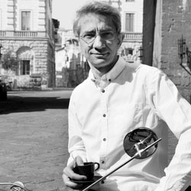Robert founded I Fagiolini in 1986 and has since spent much of his life thinking about how audiences receive music, instead of just how performers want to deliver it. Aside from his work with I Fagiolini, he is a conductor, broadcaster, educator, editor and festival director. Robert has conducted orchestras including the English Concert, Academy of Ancient Music, BBC Concert Orchestra, Irish Baroque Orchestra and directed some of the world’s finest chamber choirs including Accentus, NDR Chor, RIAS Kammerchor (Berlin), Netherlands Chamber Choir, National Chamber Choir of Ireland, BBC Singers, Danish National Vocal Ensemble and Capella Cracoviensis. Robert is Artistic Director for Stour Music Festival and the new ‘Fairest Isle Festival’ on the Isle of Wight.

At the University of York, Robert directs two choirs and the UK’s only MA in Solo-Voice Ensemble Singing, now in its 13th year. He has written and presented programmes on BBC Radio 3 and more recently created over 30 episodes of the YouTube choral series *SingTheScore* as well as co-founding and presenting the UK’s top choral podcast series, Choral Chihuahua, with Eamonn Dougan and Nicholas Mulroy, now in its twelfth season. Both are made by Polyphonic Films (Greg Browning). Robert Hollingworth is managed worldwide by Percius. [www.percius.co.uk](http://www.percius.co.uk)

This biography is valid for use until September 2026.

We update our biographies regularly. For the most up-to-date version please email [info@percius.co.uk](mailto:hannah@percius.co.uk)