Jack Liebeck
Violin/Director

Photo credit: Andrew Rankin
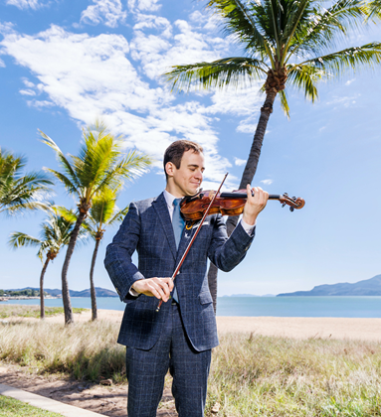
“His playing is virtually flawless in its technical ease, scintillating articulateness and purity of tone.” (Gramophone)

“Jack Liebeck lends stellar advocacy […] a sensuous warmth and rapt glow that will stop you in your tracks” (Gramophone)

”Liebeck brings a stimulating elegance and agility”
(BBC Music Magazine)

British/German violinist, director and festival director Jack Liebeck possesses “flawless technical mastery” and a “beguiling silvery tone” (BBC Music Magazine). Jack is the Royal Academy of Music’s first Émile Sauret Professor of Violin and since 2021 has been the Artistic Director of the Australian Festival of Chamber Music.

“a sensuous warmth and rapt glow that will stop you in your tracks”
(Editor’s Choice in Gramophone - Vaughan Williams’ Concerto Accademico)

Jack has collaborated with many of the world’s leading orchestras, conductors and chamber musicians in the 30 years since his debut with the Hallé Orchestra. Jack has worked with major international conductors including Sakari Oramo, Andrew Litton, Jaime Martin, Leonard Slatkin, Karl-Heinz Steffens, Sir Mark Elder, Vasily Petrenko, Brett Dean, Daniel Harding, Jukka Pekka Saraste, David Robertson, Jakub Hrůša, Jac van Steen and Santtu-Matias Rouvali, the many orchestras he’s collaborated with across the globe include the likes of: Belgian National, Swedish Radio, Royal Stockholm Philharmonic, Oslo Philharmonic, Indianapolis Symphony, St Louis Symphony, Queensland Symphony, Moscow State Symphony, Orquesta Sinfónica de Galicia, Indianapolis Symphony and all of UK orchestras.

Jack’s soulful sound, virtuosity, curiosity and passion for creative curation and collaborations through Science and the Arts has led to many notable chamber performances as well as commissions written for him including a new piece from Deborah Pritchard for Jack and VOCES8 and two concertos for Jack with regular collaborator Professor Brian Cox - Dario Marianelli’s Voyager Violin Concerto and Paul Dean’s A Brief History of Time commissioned by Melbourne Symphony Orchestra in commemoration of Professor Stephen Hawking.

In performance and on record, collaborators include the likes of VOCES8, Sheku Kanneh-Mason, Carolyn Sampson, Sasha Sitkovetsky, Roderick Williams, Mary Bevan, Nicky Spence, Lawrence Power, Renaud and Gautier Capuçon, Michael Collins, Julian Bliss, Angela Hewitt and Jean-Yves Thibaudet.
Recent highlights include Sydney Opera House with VOCES8 premiering new work Effortlessly (“goosebump material” - Limelight), Melbourne Symphony with Jaime Martin and a critically acclaimed 2025 edition of the Australin Festival of Chamber Music, which had record ticket sales.
“A diverse and interesting program, giving voice to many of the festival artists, this was a terrific offering for this year’s Australian Festival of Chamber Music.” (Limelight Magazine).

Jack is in great demand as a recording artist appearing on movie soundtracks such as Jane Eyre, Anna Karenina and The Theory of Everything. Recent album releases traverse Brahms and Schoenberg Concertos with BBC Symphony, Barber Concerto with Royal Philharmonic Orchestra, Malcolm Arnold Double Concerto with Alexander Sitkovetsky, Vaughan Williams Lark Ascending and Taylor Scott Davis To Sing of Love with VOCES8 Choir and Orchestra, Vaughan Williams Concerto Accademico and Ysaÿe Six Sonatas on Orchid Classics "...in every track Liebeck excels in capturing the fury, poetry, madness and dazzle of Ysaÿe’s haunting music. This is an exceptional release.” (The Times 5*). Jack’s extensive recording catalogue also includes the complete works for violin and orchestra by Bruch, a Kreisler compilation on Hyperion and a Brit Award winning Dvorak Concerto with the Royal Scottish National Orchestra on Sony Classics.

Jack’s Schoenberg & Brahms with BBC Symphony Orchestra was Gramophone Editor’s Choice and ‘Recording of the Month’ in BBC Music Magazine and is their ‘Recommended Recording’ for the Brahms Violin Concerto.

Jack plays the ‘Ex-Wilhelmj’ J.B. Guadagnini dated 1785 and is generously loaned a Joseph Henry bow by Kathron Sturrock in the memory of her late husband Professor David Bennett. Jack Liebeck is managed worldwide by Percius. www.percius.co.uk

This biography is valid for use until September 2026.
We update our biographies regularly. For the most up-to-date version please email info@percius.co.uk

