I Fagiolini
(Robert Hollingworth director)

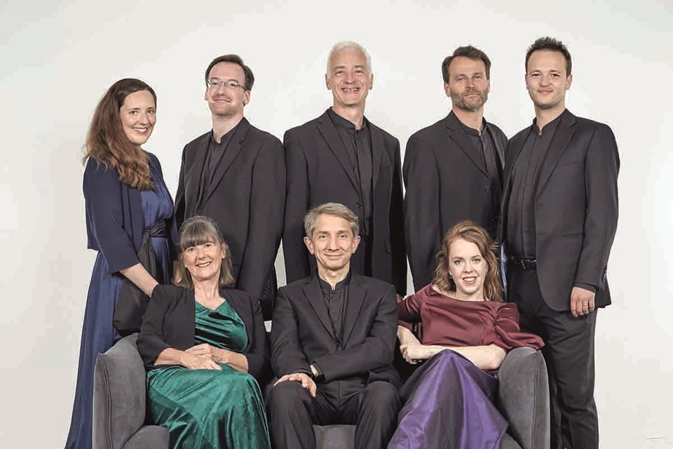
In an age of AI, I Fagiolini is a hand-painted original. The group celebrates its 40th anniversary in 26/27 and its innovative work is now as much online as it is live, including collaborative cross-art projects on stages around the world and multi award-winning music videos with Polyphonic Films: search: Goosed! and The Stag Hunt. The group’s YouTube series, SingTheScore, combines serious analysis with off-the-wall humour, while Choral Chihuahua, presented by Robert Hollingworth, Nicholas Mulroy and Eamonn Dougan, is the top UK choral podcast and is now in its twelfth season.

Signature projects include the fully immersive The Full Monteverdi and Betrayal (dir. John La Bouchardière); Tallis in Wonderland (with live and recorded voice); Simunye, the South African collaboration; and How Like An Angel with Australian contemporary circus company CIRCA for the 2012 Cultural Olympiad, and also at Perth International Arts Festival, Lincoln Center, New York and in cathedrals across Europe. The group’s French 20th-century Amuse-Bouche included the first recording of Jean Francaix’s 12-voice Ode a la Gastronomie (also on YouTube). Monteverdi programmes include L’Orfeo (dir.Tom Guthrie) with masks and puppets, and 1610 & 1641 Vespers. Leonardo - Shaping The Invisible used projections of Leonardo’s art and designs and was co-presented with Prof. Martin Kemp.

I Fagiolini’s large-scale recording projects include world premieres of Striggio ‘Mass in 40 Parts’, Viadana Vespers, works by the Gabrielis and now three albums of Benevoli’s ‘Colossal Baroque’ multi-choir masses. Consort premieres include Byrd, Tomkins, Croce, Striggio, Francaix, Milhaud and Joanna Marsh.

I Fagiolini is an Associate Ensemble at the University of York and celebrates its 40th anniversary with, ‘We’re not Dead Yet’, Monteverdi Vespers of 1610 (including a new album release), Purcell Dido and Aeneas and Monteverdi L’Orfeo! I Fagiolini is managed worldwide by Percius. www.percius.co.uk

This biography is valid for use until September 2026.
We update our biographies regularly. For the most up-to-date version please email info@percius.co.uk

