Emily Sun
Violin

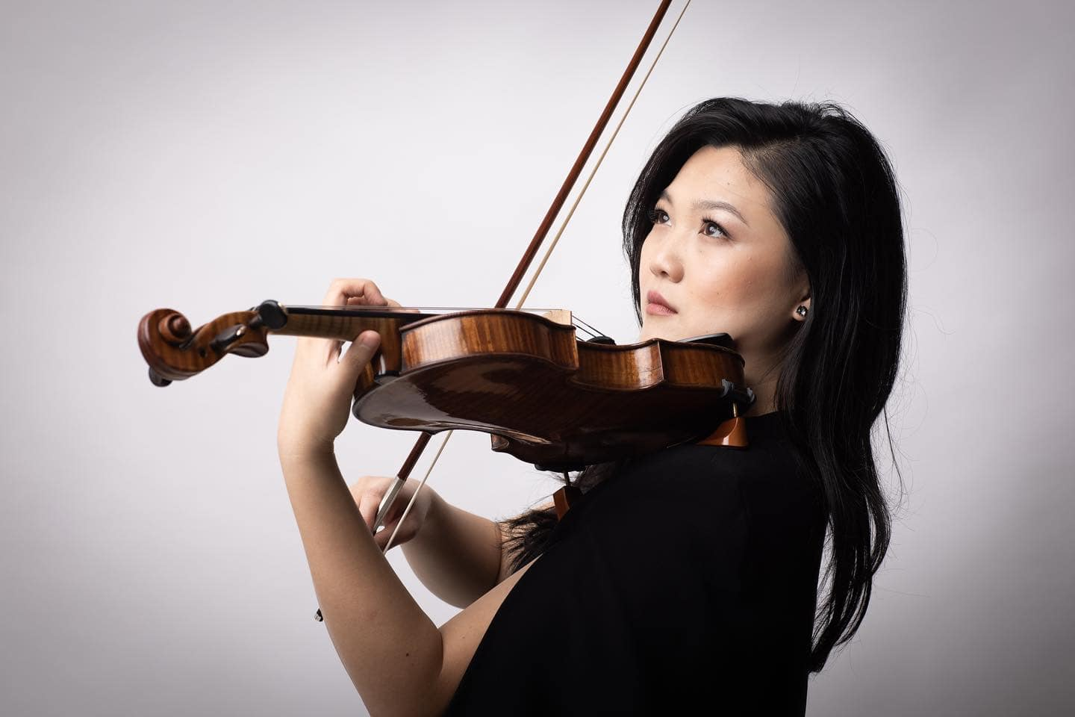
“Possessed of a superb talent” (The Australian) with “a searing and poetic tone” (The Guardian), “the flight’s of Emily Sun’s violin ... reaches heavenwards ... leaving us all in a long, stunned silence” (The Independent). Emily Sun’s powerful sound and compelling, captivating interpretations have won her international renown, just as her genuine connection with audiences and engaging presence have thrilled her growing host of supporters.
As much a chamber musician as a virtuoso, Emily originally shot to fame as a young soloist and media star in Australia, and internationally as a multi prize-winner. Now based in London and having performed with significant orchestras and in major concert halls around the globe, she is a fast-rising star with “a perfect balance of expressivity and formidable strength” (The Australian). New season returns include Queensland Symphony, Melbourne Symphony Orchestra, UKARIA and Sydney Opera House, as well as a new concerto project with composer Dani Howard.
Emily has worked with conductors such as Vasily Petrenko, Andrew Litton, Jaime Martin, Gemma New, Mark Wigglesworth, Johannes Fritzsch and Benjamin Northey. Chamber collaborations include Pekka Kuusisto, Anna Tilbrook, Maxim Vengerov, Gary Hoffman, Miguel da Silva, Marc Coppey, Danny Driver, Gemma Rosefield, Joseph Havlat and Jonathan Radford - she is invited to perform at music festivals across Europe and at halls such as Royal Albert Hall, Tchaikovsky Great Hall Moscow, Auditorium du Louvre Paris, and Flagey Brussels. Particular personal highlights include an invitation to perform at Buckingham Palace alongside Maxim Vengerov in the presence of HRH King Charles III, and at the Royal Palace of Brussels in the presence of the King and Queen of Belgium. Emily’s new duo partnership with guitarist Slava Grigoryan won rave reviews at their recent Sydney Opera House recital.
Recent orchestral performances around the world have included orchestras such as the Sydney Symphony, BBC National Orchestral of Wales (giving the UK premiere of Elena Kats-Chernin’s Fantasie im Wintergarten), West Australian Symphony, London Mozart Players, Tasmanian Symphony, Melbourne Symphony, European Union Chamber Orchestra, Orchestre de Royal Wallonie and Orchestre de Chambre Namur in Europe; Arlington and Arizona Symphonies in the USA; Shanghai Youth Orchestra and Qingdao Symphony Orchestra in China. Emily’s World Premiere of concerto Fantasie im Wintergarten, commissioned from Elena Kats-Chernin by Adelaide Symphony Orchestra for Emily in 23-24 received 5-star reviews and was hailed as “The memorable premiere of a new musical landmark” (5* Limelight Magazine) and “As always, Emily Sun gave a shining performance” (5* Artshub).
Emily’s debut album, Nocturnes with Andrea Lam reached No. 1 for four weeks in the ARIA Classical Charts and was shortlisted for ‘Best Classical Album 2021’ in the ARIA Awards. Emily released her debut concerto album Film Fantasia in Autumn 2024 on ABC Classic which includes live recordings of Kats-Chernin Fantasie im Wintergarten, Korngold Violin Concerto and Williams Theme from Schindler’s List.
As a teen, Emily shot to national fame after being featured in the acclaimed award-winning Australian documentary ‘Mrs Carey’s Concert’. Her media presence continues as an ABC Artist-in-Residence, BBC Introducing Artist, regular broadcasts on Classic FM, BBC Radio 3 (UK), Kol Hamusica (Israel), WXQR (USA), and Musiq 3 (Belgium).
Awards and prizes have included 2018 ABC Young Performers Award (Australia), the 2016 Royal Overseas League Music Competition (UK), and the Brahms (Austria), Yampolsky (Russia) and Lipizer (Italy) international violin competitions. She was a Young Concert Artist for the Tillett Trust, The Worshipful Company of Musicians and City Music Foundation.

Emily studied with Dr Robin Wilson (Sydney Conservatorium of Music), Itzhak Rashkovsky (Royal College of Music, London), Augustin Dumay (Chapelle Musicale Reine Elisabeth, Belgium), and received further mentoring from Pinchas Zukerman, Maxim Vengerov and Ivry Gitlis. Emily plays a 1753 G.B. Guadaganini, on generous loan from the UKARIA Cultural Trust, and is a Larsen Strings Artist.
Emily is violin professor at the Royal College of Music in London and is represented worldwide by Percius www.percius.co.uk and in Australia and New Zealand by Emblem Artists. www.emblemartists.com.

This biography is valid for use until August 2026.
We update our biographies regularly. For the most up-to-date version please email info@percius.co.uk

