**Barnaby Smith**

Conductor/Artistic Director/Countertenor/Producer

*”all conducted with infectious energy by Barnaby Smith... this Messiah rocked along with breathtaking fervour, but left space for contemplation... This first Messiah of the season was a winner.”* 5* The Observer

“*sublime performance… the conductor Barnaby Smith and his musicians got the Kyrie Eleison just right: portentous, magnificent, complex”* 5* The Times

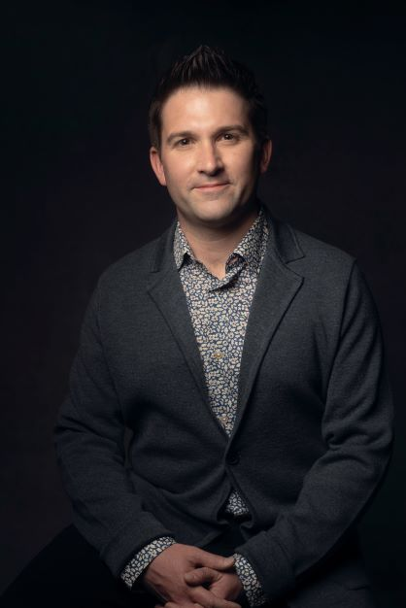**Barnaby Smith** is a Grammy-nominated conductor, countertenor, Artistic Director and producer of the internationally renowned ensemble VOCES8, the VOCES8 Foundation in the UK and USA, and the LIVE From London digital festivals. He is in demand worldwide as a performer, conductor, presenter, arranger, producer and educator.

With VOCES8 and the Foundation, Barnaby has created one of the most influential choral platforms of the 21st century, combining global touring, recording, education, and innovation. The Foundation’s education programmes now reach tens of thousands of participants annually, whilst the *LIVE From London* digital festivals, which Barnaby curates and presents, have reached audiences in more than 180 countries.

As a **conductor,** Barnaby has led distinguished choirs and orchestras across the world, from the Philharmonia, London Philharmonic and Academy of Ancient Music to major ensembles in Europe, Australia and Asia. Recent projects have included directing the Philharmonia at Abbey Road Studios, appearances with the Queensland Symphony Orchestra, and premieres of major new works such as Christopher Tin’s *The Lost Birds* and Taylor Scott Davis’s *To Sing of Love*.

As a **performer**, Barnaby has appeared at leading venues and festivals worldwide, from the BBC Proms, Royal Albert Hall, Barbican Centre, and Wigmore Hall to Sydney Opera House, Vienna Konzerthaus, Elbphilharmonie Hamburg, La Seine Musicale in Paris, Tokyo Opera City, and Palacio de Bellas Artes in Mexico City. His solo albums of Handel and Bach have received critical acclaim, with *Gramophone* noting the *“refined beauty and sheer skill”* of his singing.

Barnaby has recorded extensively with major labels including Decca Classics, Universal, Sony, Warner, Naxos, Signum, and VOCES8 Records. His discography includes six No.1 albums and numerous awards, including *Classic FM Album of the Year*. Collaborations span composers and artists such as Paul Simon, Jacob Collier, Eric Whitacre, Ola Gjeilo, Jonathan Dove, Rachel Podger, Christina Pluhar, and Roderick Williams.

A passionate **educator**, Barnaby has taught and led workshops at universities and academies worldwide. He co-curated the Master’s course in Ensemble Singing at the University of Cambridge and directs the Milton Abbey International Summer School.

Barnaby trained in Specialist Early Music Performance at the Schola Cantorum Basiliensis under Andreas Scholl and Ulrich Messthaler, and began his career as a treble in the Choir of Westminster Abbey.

As a **producer, engineer,** and **filmmaker,** Barnaby holds Dolby Atmos accreditation and has overseen a wide range of immersive audio and broadcast projects. He has produced major albums, live recordings, and the fifteen-season [*LIVE From London*](https://www.livefromlondon.org/) digital festival, acclaimed as *“a digital lifeline for the arts.”* He also creates and directs all of VOCES8’s media output, which has been central to building the group’s global online presence, with millions of listeners and viewers around the world. His production work has supported collaborations with ensembles including Th–e Sixteen, Gabrieli Consort, Chanticleer, the Academy of Ancient Music, and The King’s Singers.

Barnaby Smith is managed worldwide by Percius: [www.percius.co.uk](http://www.percius.co.uk).

*“Smith’s instrument is sweet, intense and bursting with colours... shapely phrases, like his blistering speed and crisp passage in ‘Venti turbini’ (Rinaldo), are indebted to muscle and musicianship alike”* - BBC Music Magazine

*“’The Messiah’ which went with a swing both fresh and joyous — VOCES8 as Artists in Residence more than put their stamp on the festival… led by Barnaby Smith, a musical general who spearheaded all the musical endeavours and thus ensured quality in a class of its own… Jubilation and standing ovations at the close.”* - Kultur, Graz

This biography is valid for use until September 2026.

We update our biographies regularly. For the most up-to-date version please email [info@percius.co.uk](mailto:hannah@percius.co.uk)