I Fagiolini
(Robert Hollingworth director)

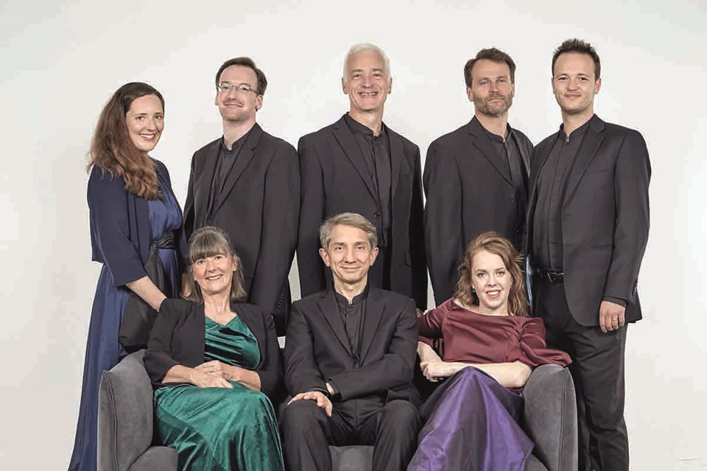
I Fagiolini is internationally renowned for its genuinely innovative productions, which are as much online as live, including world premiere recordings, collaborative cross-art projects, education and short (multi award-winning) music videos with Polyphonic Films. “The group are musical shapeshifters, following Hollingworth's giddy, eclectic imagination wherever it leads.” (The Spectator).

I Fagiolini looks towards its 40th year in 2026 with inspirational and engaging programmes. Ranging from large-scale, world premiere, multi-choir masses by 17th century composer Orazio Benevoli, to consort anniversary Britten, signature Monteverdi (including its 1610 Vespers Unwrapped at Kings Place), and its trademark commissioning and collaborations - a brand new eight-album deal with CORO will share releases to mirror the group’s touring programmes. I Fagiolini’s three album releases in 23/24 include the world premiere recording of Benevoli Missa Tu es Petrus (5* in Limelight and described as “musical magic” by Gramophone), low pitch Victoria Tenebrae Responsories for Easter 2024 and newly re-mastered multi award-winning Striggio Mass in 40 Parts and Tallis Spem in Alium - a 40th anniversary Monteverdi album in 2026 will complete the set.

“achieving a thrilling synergy of articulate instrumental playing, fulsome choral ripienos and dexterous solo singing” (Gramophone).

Signature projects include the fully immersive The Full Monteverdi and Betrayal (dir. John La Bouchardière); Tallis in Wonderland (with live and recorded voice); Simunye, the South African collaboration; How Like An Angel with Australian contemporary circus company CIRCA for the 2012 Cultural Olympiad, the show debuted in Perth International Arts Festival, Lincoln Center, New York and in cathedrals across Europe. In recent years the group’s French 20th century Amuse-Bouche included the first recording of Jean Francaix’s 12-voice Ode a la Gastronomie (also a film). Sacred and secular programmes for Monteverdi’s 450th included L’Orfeo (dir.Tom Guthrie) with masks and puppets; and Leonardo - Shaping The Invisible, with Professor Martin Kemp and projections of Leonardo’s art and designs.

I Fagiolini has created a host of new programmes for The VOCES8 Foundation’s LIVE From London festivals: Re-Wilding The Waste Land with Tamsin Greig; Long, long ago - an alchemic mix of Charpentier, Howells & Dylan Thomas; and Angels & Demons which features Rachel Podger and Brecon Baroque alongside its singers in Bach, Monteverdi and a high-energy Neapolitan 17th century pantomime (currently touring). These alongside the group’s renowned film shorts, most recently GOOSED, based on Giovanni Croce's carnival masque Il gioco dell'oca (The Game of the Goose) and award-winning THE STAG HUNT, a modern satire about aristocracy, extinction and the environment, based on La Chasse by Renaissance composer Clément Janequin, directed by John La Bouchardière. Also online, the group’s YouTube series, SingTheScore, combines serious analysis with off-the-wall humour. Director Robert Hollingworth’s podcast series Choral Chihuahua highlights issues and sector personalities and is now in its sixth season (with Nicholas Mulroy and Eamonn Dougan).

I Fagiolini has released 23 recordings to date. Previous recordings include Leonardo: Shaping the Invisible on CORO which received high acclaim upon release; “Yet again, the eight-strong vocal ensemble... has come up with an ingenious "concept" programme that stirs the mind and heart, illuminates the past, and ravishes the ear” (The Telegraph). I Fagiolini’s last CORO release, John Wilbye Draw On Sweet Night, won the German Record Critics' Award (Preis der Deutschen Schallplattenkritik). “Sophisticated madrigalists - vocal lines emerging with emotional intelligence and impressive control. It’s very classy entertainment.” (BBC Radio 3 Record Review). Previous Decca Classics discs include Amuse-Bouche - French Choral Delicacies and 1612 Italian Vespers.

The group is delighted to be Associate Ensemble at the University of York. I Fagiolini is managed worldwide by Percius. www.percius.co.uk

This biography is valid for use until January 2024.
We update our biographies regularly. For the most up-to-date version please email info@percius.co.uk

