Simon Crawford-Phillips
Conductor/Director/Pianist

“The conductor Simon Crawford-Phillips proved to be an enthralling figure both as a musician and a stage persona… energetic, fast, constantly and thrillingly on the front foot.” (Västmanlands Tidning).

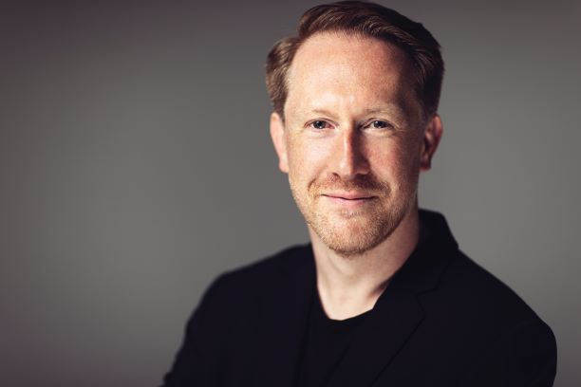
Simon is a multi-festival director, conductor, renowned pianist, creative programmer with a passion for championing contemporary repertoire, and a chamber musician who regularly collaborates with artists such as Daniel Hope, Lawrence Power, Roderick Williams and Anne Sofie von Otter in repertoire from Haydn and Schumann to Adès, Byström, Dean and Reich. His own ensembles include The Kungsbacka Piano Trio and Stockholm Syndrome Ensemble (resident artists at Stockholm Konzerthus). Simon is the Artistic Director of the Change Music Festival in Norra Halland, Västerås Music Festival and Co-Artistic Director of the Wye Valley Chamber Music Festival as well as Chief Conductor & Artistic Advisor of Västerås Sinfonietta, alongside multiple guesting roles.

Simon’s spicy and eclectic programming is reflected in an extraordinarily varied career as a conductor/director alongside his solo collaborations. His triumphant season has included conducting debuts with Royal Swedish Opera in Britten’s A Midsummer Night’s Dream, which was Norman Lebrecht’s Opera of the week and SvenskaDagbladet wrote “The Swedish Royal Opera Orchestra under the direction of Simon Crawford-Phillips manage to reveal the myriad of temperament and structure that the music contains, without the dreaminess disappearing”; Royal Stockholm Philharmonic, the world premiere of Börtz Violin Concerto for One with Malin Broman and Norrköpings Symfoniorkester; directing the Norwegian Chamber Orchestra in a joint programme with Pekka Kuusisto; and the world premiere of a new double concerto from Finnish composer Sauli Zinovjev for him as director/soloist and Hugo Ticciati with Tapiola Sinfonietta.

Upcoming conducting debuts for Simon include Royal Stockholm Philharmonic Orchestra, Helsinki Philharmonic, Scottish Chamber Orchestra with Pekka Kuusisto, Swedish Chamber Orchestra and Neubrandenburg Philharmonic Orchestra in Britten and Berlioz. Reinvites include Uppsala, Zurich Chamber Orchestra, Ostrobothnian Chamber Orchestra, Nordic Chamber Orchestra, Jönköping Sinfonietta and Musica Vitae for a programme of Tippett, Wallen, Gerswhin & Bloch.

Recent conducting engagements include Gothenburg Symphony, Uppsala (world premiere of Monnakgotla Saxophone Concerto with Johannes Thorell), Helsingborg Symphony, Dalasinfoniettan Nordic Chamber Orchestra, directing Sinfonia Varsovia in Warsaw’s Lutosławski Chain Festival, and debuting Wild Waves and Woods at Kings Place with Västerås Sinfonietta, Paul Watkins and Lawrence Power. He also made his debut with Zurich Chamber Orchestra for an extensive European tour alongside Daniel Hope. Simon has conducted the BBC National Orchestra of Wales, Nash Ensemble, the Swedish Radio Symphony, Aalborg Symphony, Polish Chamber, and English Chamber orchestras. Previously Simon was Conductor Fellow of the NDR Elbphilharmonie Orchestra, working alongside chief conductor Alan Gilbert as well as assisting Daniel Harding, Alain Altinoglu and Stanislav Kochanovsky at the Verbier Festival.

In 2017 Simon was appointed Artistic Adviser and Chief Conductor of Västerås Sinfonietta. He has broadened the Sinfonietta’s reach and repertoire as well as launching the Sinfonietta’s own festival. Västerås Sinfonietta’s recent disc release, for BIS, features the world premiere recording of Albert Schnelzer’s Burn my letters and A Freak in Burbank.

As a pianist The Guardian says Simon has “profound sensitivity and technical brilliance, achieving an
expressive intensity that made for compelling listening.” He performs in premiere festivals and concert halls across Europe including Verbier, Schleswig-Holstein, Edinburgh, and at Wigmore Hall where he will appear as the regular pianist with Chamber Ensemble in Residence, the acclaimed Nash Ensemble, and in recital with Daniel Hope, Lawrence Power, and Phillip Moore. Notable concerto debuts include the NHK Symphony Orchestra under the baton of Alan Gilbert, BBC Scottish Symphony Orchestra under Ilan Volkov and the Swedish Radio Symphony Orchestra directing from the keyboard. Upcoming performances include a US tour with Daniel Hope and further performances with Pekka Kuusisto, Lawrence Power and his own ensembles.

Additional regular collaborators include artists such as Colin Currie, Anthony Marwood, Truls Mørk, Anne Sofie von Otter, Phillip Moore, Michael Schade, Roman Simović, Torleif Thedéen, and the Danish and Elias string quartets. Passionate about contemporary music Simon has recently given world premieres of music by Thomas Adès, Britta Byström, Steve Reich and Mark-Anthony Turnage as well as working alongside composers Sofia Gubaidulina, Simon Holt, Colin Matthews and Huw Watkins.

Further highlights include album releases: Byström-Brahms Diagonal Music on Alba featuring Brahms Horn Trio & Zwei Gesänge with Malin Broman and Chris Parkes. Simon appears on Daniel Hope’s solo release Belle Epoque and Fin de Siecle - Enescu, Debussy, Ravel and Webern for Deutsche Grammophon. Simon released Fanny and Felix for dB Productions, Felix Mendelssohn’s Double Concerto for Piano, Violin and Strings alongside Fanny Hensel Mendelssohn’s String Quartet recorded for the first time in an arrangement for string orchestra - both with Malin Broman and award-winning Swedish string orchestra, Musica Vitae. For BIS, The Kungsbacka Trio have released two volumes of Complete Schumann Piano Trios, and the Stockholm Syndrome Ensemble released Voices of Angels (Dean, Gubaidulina, Rachmaninov). Simon appears with the Nash Ensemble for Hyperion (Fanny Mendelssohn and Clara Schumann), and Västerås Sinfonietta’s recording, Nightingale. Simon has also recorded for Channel Classics, Deux-Elles, Harmonia Mundi, LSO Live, Naxos, Nonesuch and Signum Classics. In addition to radio and television broadcasts in Europe, Australia and Japan Simon has also presented concerts for Sweden’s classical music radio station P2.

A renowned teacher, Simon was elected a Fellow of the Royal Academy of Music in 2010 and currently teaches at the Gothenburg Academy of Music and Drama. Recent guest teaching has included the Schymberg masterclasses in Sweden together with Anne Sofie von Otter and chamber music at Indiana University in Bloomington and the University of Colorado. Simon Crawford-Phillips is managed worldwide by Percius www.percius.co.uk.

This biography is valid for use until January 2024.
We update our biographies regularly. For the most up-to-date version please email info@percius.co.uk

