Emily Sun
Violin

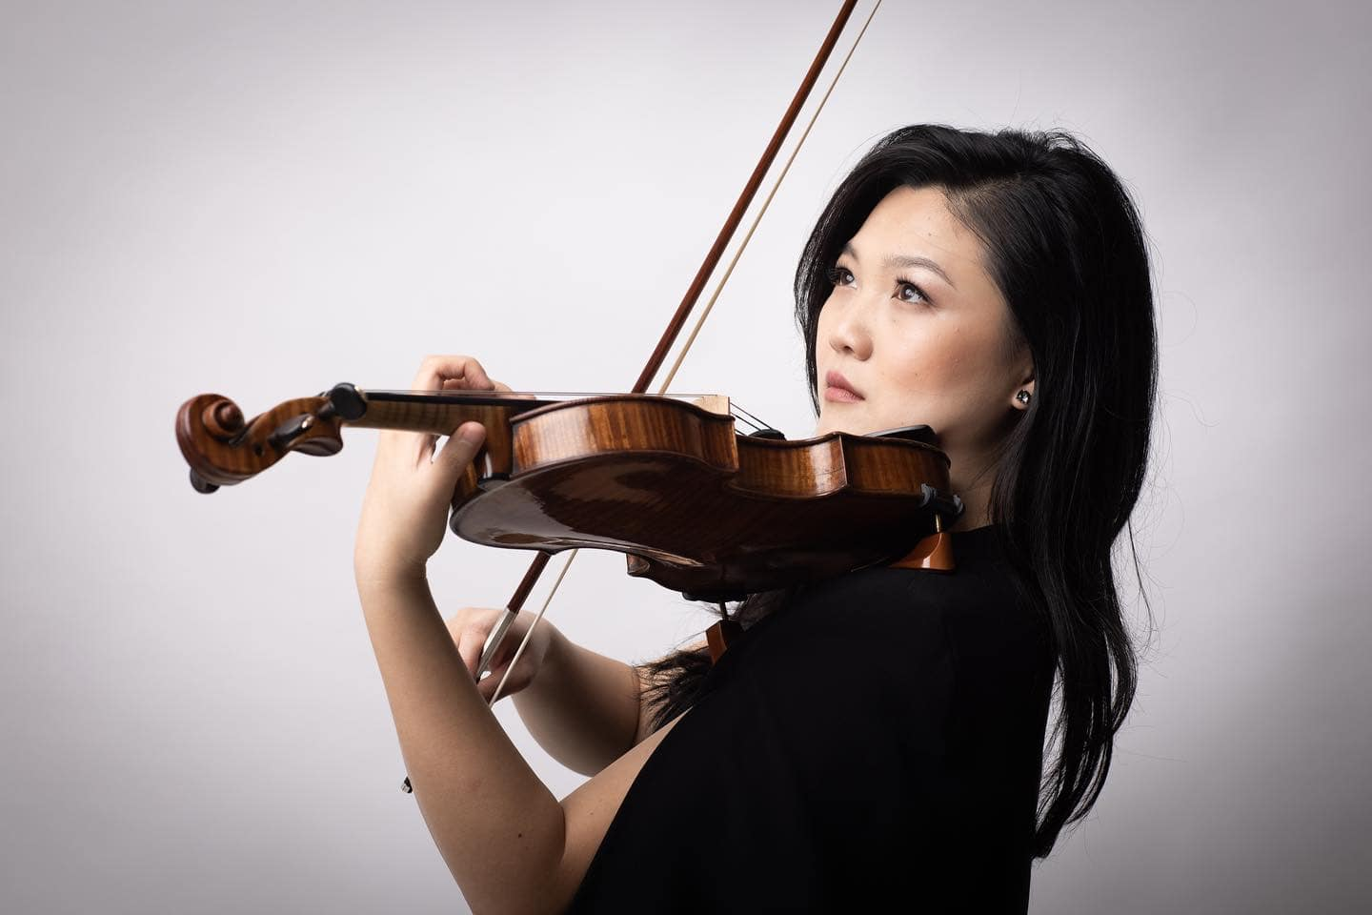
“Possessed of a superb talent” (The Australian) with “a searing and poetic tone” (The Guardian), “the flight’s of Emily Sun’s violin.. reaches heavenwards.. leaving us all in a long, stunned silence” (The Independent). Emily Sun’s powerful sound and compelling, captivating interpretations have won her international renown, just as her genuine connection with audiences and engaging presence have thrilled her growing host of supporters.

As much a chamber musician as a virtuoso, Emily originally shot to fame as a young soloist and media star in Australia, and internationally as a multi prize-winner. Now largely based in London and having performed with significant orchestras and in major concert halls around the globe, she is a fast-rising star with “a perfect balance of expressivity and formidable strength” (The Australian).

Emily is Adelaide Symphony Orchestra’s Artist in Association 2023. The residency includes a new concerto commissioned from Elena Kats-Chernin by ASO for Emily, which received 5 star reviews “The memorable premiere of a new musical landmark, Elena Kats-Chernin’s violin concerto, featuring a wondrous performance by violinist Emily Sun”(5* Limelight Magazine) and the Australian premiere of Fazil Say’s Violin Sonata No 2 ‘Kaz Daglari’.

Upcoming projects include recordings and performances with the Sydney Symphony Orchestra (Mark Wigglesworth) at Sydney Opera House, Barber with Andrew Litton and the Adelaide Symphony as well as Bruch with Shiyeon Sung, Korngold with Johannes Fritzsch and Tasmania Symphony, Bendigo Chamber Music Festival, and London Mozart Players. Emily will make her debut with Johannesburg Philharmonic and return to Western Australia Symphony Orchestra to play Beethoven’s Violin Concerto with Asher Fisch.

Recent performances have included Mozart with Western Australia Symphony Orchestra (under Vasily Petrenko), Tchaikovsky’s Violin Concerto with Melbourne Symphony Orchestra (under Jaime Martin) as well as under Associate conductor Benjamin Northey performances of Korngold and John Williams’ Schindler’s List for ABC Classics ‘Classic 100’ which was broadcast on radio & TV. Chamber recitals across the world include Music in the Round, a duo partnership with pianist Anna Tilbrook, Joseph Havlat at 1901 Club and a residency at the Australian Chamber Music Festival.

Emily’s solo album, Nocturnes, was released on ABC Classics/Universal to critical acclaim; it reached No. 1 for four weeks in the ARIA Classical Charts and was shortlisted for ‘Best Classical Album 2021’ in the ARIA Awards. Emily also features in a Rubicon Classics disc on the forgotten chamber works of Robert Kahn which received a 5-star review from BBC Music Magazine. Emily’s next release for ABC Classics in Spring 2024 will be a concerto disc of Korngold, Williams and the world premiere recording of the new Kats-Chernin concerto.

As a concerto soloist, Emily has appeared globally with orchestras including all the Australian symphony orchestras, the European Union Chamber Orchestra, Orchestre de Royal Wallonie and Orchestre de Chambre Namur in Europe; Arlington and Arizona Symphonies in the USA; and Shanghai Youth Orchestra and Qingdao Symphony Orchestra in China.

Significant concert venues performed at include the Sydney Opera House, Wigmore Hall, Royal Albert Hall, Bridgewater Hall Manchester, Tchaikovsky Great Hall Moscow, Auditorium du Louvre Paris, and Flagey Brussels. Emily was invited to perform at Buckingham Palace alongside Maxim Vengerov in Bach’s Double Violin Concerto at the Royal Gala in the presence of HRH Prince of Wales, and at the Royal Palace of Brussels in the presence of the King and Queen of Belgium. Chamber collaborators have included Maxim Vengerov, Gary Hoffman, Miguel da Silva, Marc Coppey, Danny Driver, Gemma Rosefield and is regularly invited to perform at music festivals across Europe.

As a teen, Emily shot to national fame after being featured in the acclaimed award-winning Australian documentary ‘Mrs Carey’s Concert’. Her media presence continues as the ABC Artist-in-Residence, BBC Introducing Artist, regular broadcasts on Classic FM, BBC Radio 3 (UK), Kol Hamusica (Israel), WXQR (USA), and Musiq 3 (Belgium).

Awards and prizes have included the Tagore Gold Medal from the Royal College of Music, the 2018 ABC Young Performers Award (Australia), the 2016 Royal Overseas League Music Competition (UK), and the Brahms (Austria), Yampolsky (Russia) and Lipizer (Italy) international violin competitions. She was a Young Concert Artist for the Tillett Trust, The Worshipful Company of Musicians and City Music Foundation.

Emily studied with Dr Robin Wilson (Sydney Conservatorium of Music), Itzhak Rashkovsky (Royal College of Music, London), Augustin Dumay at Chapelle Musicale Reine Elisabeth, Belgium, and received further mentoring from Pinchas Zukerman, Maxim Vengerov and Ivry Gitlis. Emily is herself a passionate pedagogue and Violin professor at the Royal College of Music, London.

Emily plays a 1760 Nicolo Gagliano violin, kindly loaned to her through the Beare’s International Violin Society. Emily Sun is represented worldwide by Percius www.percius.co.uk and in Australia by Cinque Artist Management.

This biography is valid for use until January 2024.
We update our biographies regularly. For the most up-to-date version please email info@percius.co.uk

