Barnaby Smith
Conductor/Artistic Director/Countertenor

”all conducted with infectious energy by Barnaby Smith... this Messiah rocked along with breathtaking fervour, but left space for contemplation... This first Messiah of the season was a winner.” 5* The Observer

“sublime performance… the conductor Barnaby Smith and his musicians got the Kyrie Eleison just right: portentous, magnificent, complex” 5* The Times

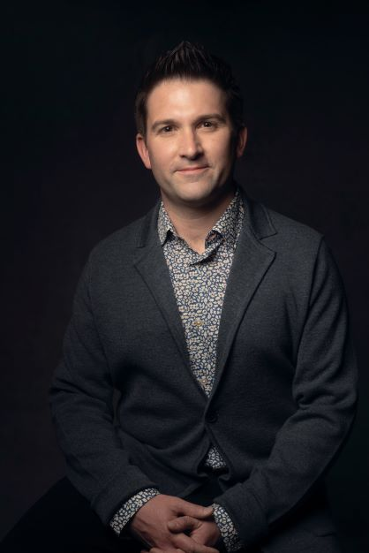
Grammy-nominated, Barnaby Smith is Artistic Director of the internationally renowned vocal ensemble VOCES8, LIVE From London digital festivals, and the UK and US arms of The VOCES8 Foundation including its Digital Academy and Milton Abbey Festival. He is in demand as a conductor, presenter, film-maker, choir trainer, countertenor and arranger.
Amongst a busy touring, education, filming and conducting schedule with VOCES8 and ensembles around the world, recent projects have included Barnaby’s debut with Nederlandse ReisOpera in Handel Messiah, two solo-recordings Handel & Bach, of which - Gramophone notes that there is “no denying the refined beauty and sheer skill of Smith’s performance” as well as producing and presenting the 10th LIVE From London Festival. Collaborations with Eric Whitacre and Paul Simon continued, resulting in two new albums – Home (reaching No.1 in the Classical Album chart and awarded a BBC Music Magazine Choral and Song Choice) and Seven Psalms (which garnered wide-ranging 5 star reviews and high praise from Rolling Stone magazine). Future releases include Decca’s Christmas 2023 album release of A Choral Christmas on which Barnaby conducts festive works by Taylor Scott Davis and a third solo - Pergolesi’s Stabat Mater, due in 2024. Barnaby will direct VOCES8, Ola Gjeilo and Carducci Quartet in BBC Prom 34: Mindful Mix. The following seasons include debut conducting appointments with Queensland Symphony Orchestra (Vaughan Williams and Tin The Lost Birds), and return projects with the Academy of Ancient Music (Handel Israel in Egypt) and Nederlandse Reisopera.
Barnaby has performed at many of the world's prestigious festivals and halls including BBC Proms, Royal Albert Hall, the Barbican Centre, Wigmore Hall, Bridgewater Hall, Sydney Opera House, Muziekgebouw Amsterdam, La Seine Musicale and Cité de la Musique in Paris, Elbphilharmonie Hamburg, BOZAR in Brussels, Tokyo Opera City, NCPA Beijing, Mariinsky Theatre Concert Hall, Victoria Concert Hall in Singapore, Palacio de Bellas Artes in Mexico City and Vienna Konzerthaus.
Barnaby has conducted orchestras including the Philharmonia Orchestra, the Academy of Ancient Music, Australian National Academy of Music, English Chamber Orchestra, London Philharmonic Orchestra, Tokyo Philharmonic Orchestra, Monte Carlo Symphony and he directed the music for the Olympic Mascots Film Scores at Abbey Road Studios with the British Film Orchestra. He conducted the VOCES8 Foundation Choir and Orchestra in the premiere of Christopher Tin The Lost Birds alongside new arrangements of Eric Whitacre Sleep, Caroline Shaw and the swallow, and a new adaptation of The Lark Ascending for violin, choir, and orchestra.
Barnaby’s collaborations have included projects with Paul Simon, Rachel Podger, Roderick Williams, Christina Pluhar, Jack Liebeck, Masaki Suzuki, Jacob Collier, Ola Gjeilo, Eric Whitacre, Jonathan Dove and Christopher Tin amongst others. Digital collaborations have included The Sixteen, the English Chamber Orchestra, Gabrieli Consort & Players, The King's Singers, The Tallis Scholars, the Academy of Ancient Music and Chanticleer. A passionate pedagogue, he has taught at Academies and Universities across the world including co-curating the Master's course in ensemble singing at the University of Cambridge and at Milton Abbey International Summer School. Other activities have included curating and producing the LIVE From London digital festival, now in its 10th Season having reached audiences in over 180 territories across the world and commissioning a new violin concerto for Jack Liebeck, choir and orchestra To Sing of Love from composer Taylor Scott Davis. To Sing of Love will be premiered digitally this year - with live premieres and recording plans for next year are in discussion.
On disc Barnaby has released albums with record labels including Decca Classics, Universal, Sony, Warner, Naxos, Signum Classics and VOCES8 Records. He has six No.1 albums to his credit and has won numerous awards including Classic FM Album of the Year. He has released two solo albums on VOCES8 Records, Handel, with guest Mary Bevan in October 2021 and Bach with the Illyria Consort in February 2023. Barnaby conducted the Philharmonia for the world premiere recording of Mårten Jansson and Charles Anthony Silvestri's Requiem Novum. Recent releases with VOCES8 include Infinity (Decca Classics), After Silence (VOCES8 Records) and Home (Decca Classics).
Barnaby completed his studies in Specialist Early Music Performance at the Schola Cantorum Basiliensis where he was a pupil of Andreas Scholl and Ulrich Messthaler. He is an alumnus of the Britten-Pears Young Artists Programme and began his career singing as a treble in The Choir of Westminster Abbey. Barnaby Smith is managed worldwide by Percius. www.percius.co.uk
“’The Messiah’ which went with a swing both fresh and joyous — VOCES8 as Artists in Residence more than put their stamp on the festival… led by Barnaby Smith, a musical general who spearheaded all the musical endeavours and thus ensured quality in a class of its own… Jubilation and standing ovations at the close.” Kultur, Graz

This biography is valid for use until January 2024.
We update our biographies regularly. For the most up-to-date version please email info@percius.co.uk

