Rachel Podger and Brecon Baroque

“Podger – and Brecon Baroque – didn’t miss a trick. Thrillingly three-dimensional.” (York Press)

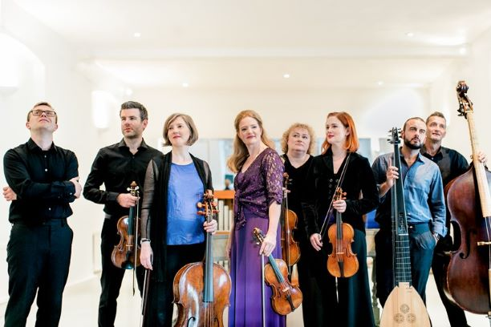
“Magnificent Brecon Baroque are masters of an impressive palette” (Diapason D’Or). The dynamic ensemble Brecon Baroque consists of an international line-up of world-class virtuosi in the period-instrument world. Together they specialise in one-to-a-part repertoire including Vivaldi, Biber, and Bach which “releases a freedom and buoyancy in the playing” (Financial Times) and spotlights each member alongside group director Rachel Podger.

The new season includes a residency at Kings Place as part of Rachel’s Artist in Focus year; continued tours of Vivaldi The Four Seasons to support its Vivaldi concerti box-set release on Channel Classics and the piece’s 300th anniversary; the album release and London premiere of Bach Goldberg Variations Reimagined arranged especially for Rachel and Brecon Baroque by Chad Kelly and due out in autumn 2023 on Channel Classics; a Christmas tour with I Fagiolini of Angels and Demons which has taken the group across the UK; new Bach and Biber programmes including From Darkness to Light; and a tour and album release in Spring 2024 of Biber 1681 Sonatas.

The group has performed across the world including at the Wigmore Hall as part of Rachel Podger’s Artist in Residency, Edinburgh International Festival, tours of continental Europe and Japan, and performances at their very own Brecon Baroque Festival. Rachel and Brecon Baroque’s debut CD, Bach Violin Concertos, attracted universal critical acclaim and was quickly hailed as a benchmark recording of these works. The complete recording of Vivaldi L'Estro Armonico concertos was Record of the Month for both the BBC Music Magazine and Gramophone Magazine, was awarded a Diapason d’Or, and won the 2016 BBC Music Magazine Concerto Award. In 2016, their disc of Biber Rosary Sonatas won the Baroque Instrumental Gramophone Award, followed by the release of Bach Art of Fugue and Grandissima Gravita in 2017. The much-anticipated recording of Vivaldi Le Quattro Stagioni was released in 2018 to superb international reviews and won many awards “this is something genuinely, effortlessly and naturally different … a Four Seasons to covet and keep” (Gramophone). Brecon Baroque is managed worldwide by Percius. www.percius.co.uk

“Fresh…Podger and co send thunderbolts flying in all directions…a shimmer of opulent exuberance.”
BBC Music Magazine, Concerto Choice Album of the Month

This biography is valid for use until January 2024.
We update our biographies regularly. For the most up-to-date version please email info@percius.co.uk

