"'Neave' is a Gaelic name meaning 'bright' and 'radiant', both of which certainly apply to this trio's music making." (WQXR)
Neave Trio
Piano Trio
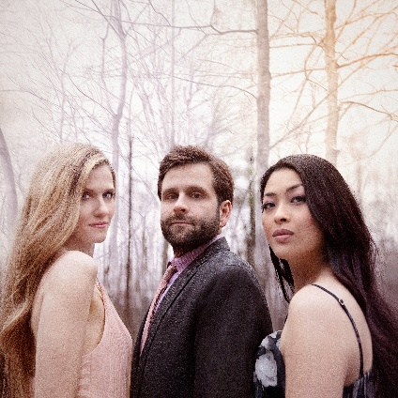
Anna Williams – violin
Mikhail Veselov – cello
Eri Nakamura - piano

Forged out of friendship and honed by passion, the Neave Trio has earned enormous praise for its engaging, cutting-edge performances, innovative collaborations and its championing of works by living composers. The Trio’s recordings have been named among the best recordings of the year by both The New York Times and BBC Radio 3, and Gramophone notes their performances as “thrilling, wild energy, electrifying”.

Neave has performed at esteemed concert series and festivals worldwide including Lincoln Center’s Mostly Mozart Festival, Carnegie Hall’s Weill Recital Hall, Smithsonian American Art Museum, Kaatsbaan Summer Festival, Bard Music Festival, Rockport Chamber Music Festival, La Jolla Athenaeum, as well as performances across Europe, Japan and Russia.

Of particular note for Neave upcoming are the world premieres of three works written for the trio: Robert Paterson’s new triple concerto on the topic of climate change, to be premiered in June ‘23 under the baton of JoAnn Falletta at the Mostly Modern Festival, and new works from celebrated composers Jennifer Higdon and Jonah Sirota. Anticipated recording and touring programmes include the beautiful ‘A room of her own’ around Smyth, Tailleferre, Boulanger and more.

Innovative programming and collaborations with artists of many mediums are a hallmark of the Neave’s work, its current collaborations include: Rising, an exploration of what it means to rise with PigeonWing Dance, choreographer Gabrielle Lamb and American composer, Robert Sirota; Gathering Light, an immersive evening of sight and sound created with media artist Sharon Harper, which premiered at Harvard University in 2022; D-Cell: an Exhibition & Durational Performance, conceived and directed by multi-disciplinary visual artist David Michalek; as well as performances with the Blythe Barton Dance Company; with dance collective BodySonnet; with projection designer Ryan Brady; and in the interactive concert series “STEIN2.0”. Working with living composers, Neave Trio’s recent premiere performances include Klee Musings by acclaimed American composer Augusta Read Thomas, Eric Nathan’s Missing Words V, recorded for New Focus Recordings, Elena Ruehr’s Winter Night, Leah Read’s Cloud Burst for piano trio and electronics, and Dale Trumbore’s Another Chance, among others.

Members of the Neave are dedicated educators and the trio has held residency positions at Brown University, MIT School of Architecture and Design, University of Virginia, San Diego State University as the first ever Fisch/Axelrod Trio-in-Residence, Longy School of Music of Bard College, and the Banff Centre (Canada). During 2022-2023 season, Neave Trio will be visiting ensemble-in-residence at both the Mostly Modern Festival (New York) as well as Wartburg College (Iowa).

Neave’s critically acclaimed recordings include Musical Remembrances (Chandos Records, 2022), in which the Wall Street Journal highlighted “the expressive alchemy among the players”; Her Voice (Chandos, 2019), which Gramophone described as “a splendid introduction to these three pioneering female composers,” and as “sumptuously recorded … a taut and vivid interpretation”. Other recent releases include Celebrating Piazzolla (Azica Records), French Moments (Chandos) as well as the trio’s debut album in 2016, American Moments (Chandos).

Whilst the COVID-19 pandemic shut concert halls around the world, the Neave Trio found meaningful ways to continue to perform safely and engage with its audiences. Particular moments of note were a film of Anna and Mikhail giving an emotional and heartfelt performance of Leonard Cohen's Hallelujah in support of their neighbour and all essential workers during the coronavirus crisis - the video was shared by PBS’ American Portrait series and has over 1 million views. Neave also performed virtual concerts for The Violin Channel's "Living Room Live" series and for the “Notes of Hope: Music for the Frontline” series.

“it is inconceivable that they will not soon be among the busiest chamber ensembles going…
their unanimity, communication, variety of touch, and expressive sensibility rate first tier”
(The Boston Musical Intelligencer)

The Neave Trio is managed in North America by Jensen Artists and by Percius (www.percius.co.uk) for the rest of the world.

This biography is valid for use until September 2023.
We update our biographies regularly. For the most up-to-date version please email info@percius.co.uk

