Rachel Podger
Baroque Violin/Director

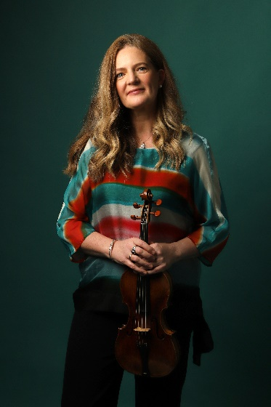
“Rachel Podger, the unsurpassed British glory of the baroque violin,” (The Times) has established herself as a leading interpreter of the Baroque and Classical. She was the first woman to be awarded the prestigious Royal Academy of Music/Kohn Foundation Bach Prize in October 2015, Gramophone Artist of the Year 2018, and the Ambassador for REMA’s Early Music Day 2020. A creative programmer, Rachel is the founder and Artistic Director of Brecon Baroque Festival and her ensemble Brecon Baroque; she is Principal Guest Director for Tafelmusik for the 24-25 and 25-26 seasons; Artist in Focus at Kings Place for 23-24; Patron for The Continuo Foundation and an Ambassador for the Learned Society of Wales. Rachel is the 2023 BBC Music Magazine Recording of the Year and Instrumental Award winner for her solo album Tutta Sola.

Rachel continues to broaden her collaborations with orchestras, ensembles and venues worldwide. Upcoming highlights include her debut directing Budapest Festival Orchestra, a return to direct the Handel and Haydn Society, and performances at venues such as BOZAR, Lincoln Center, Wigmore Hall and LSO St Lukes. A tour of Angels and Demons with I Fagiolini beckons, alongside a Vivaldi tour with Arte dei Suonatori, the Austrian premiere of A Guardian Angel with VOCES8 at Vienna Konserthaus, and Bach Goldberg Variations Reimagined and Vivaldi The Four Seasons with Brecon Baroque.

As a director, soloist and chamber musician, Rachel has collaborated with many artists including Robert Levin, Jordi Savall, Christopher Glynn, Kristian Bezuidenhout, Masaaki Suzuki, Philharmonia Baroque, Orchestra of the Age Enlightenment, San Francisco Early Music, Holland Baroque Society, and Oregon Bach Festival.

Forthcoming album releases on Channel Classics include the world premiere recording of Bach Goldberg Variations Reimagined in a new chamber arrangement by Chad Kelly with Brecon Baroque which will be released in October ’23; a recording of Biber’s improvisatory 1681 Sonatas will follow in Spring 2024. A 7CD boxset of her award-winning Vivaldi concertos and an album of C.P.E. Bach, with duo partner Kristian Bezuidenhout, were released in Spring 2023 both to rapturous acclaim including a Classic FM ‘Album of the Week’ for the Vivaldi box-set and BBC Music Magazine awarded Rachel & Kristian a double five star rating for C.P.E. Bach saying "Their music-making is infectiously spontaneous yet tellingly 'considered' - seamless rapport and impeccably-judged articulation delighting in a stream of illuminating felicities".

Other releases include the world premiere of three previously unfinished Mozart sonatas and Beethoven Sonatas 1, 5, and 10, both with Christopher Glynn: “This selection stands out for its individuality and a characteristic refusal to take the music at face value." (Gramophone); Vivaldi Le Quattro Stagioni with Brecon Baroque and Bach Cello Suites transposed for the violin, which according to BBC Music Magazine, the five-star album is “a spellbinding set that is arguably Podger's finest recorded achievement to date…one would naturally assume the suites were violin originals after experiencing her life-enhancing playing." Numerous awards have included two Baroque Instrumental Gramophone Awards for La Stravaganza (2003) and Biber Rosary Sonatas (2016), Opus Klassik for Tutta Sola, the Diapason d’Or de l’année in the Baroque Ensemble category for her recording of the La Cetra Vivaldi concertos (2012), two BBC Music Magazine awards in the instrumental category for Guardian Angel (2014) and the concerto category for the complete Vivaldi L’Estro Armonico concertos (2016).

Rachel has featured in The VOCES8 Foundation’s LIVE From London festival three times – in a new advent version of A Guardian Angel, "a sensitive accompanist when called for and displayed nimble fingers in her virtuosic solos” (Wall Street Journal), alongside I Fagiolini in their Christmas programme Angels and Demons and most recently in La Passione: Haydn & Mozart with Tafelmusik Baroque Orchestra and Choir. She performed solo Bach for Gramophone Magazine’s Winners’ Digital Gala’, appeared in Bitesize Proms, BOZAR at Home, Living Room Live, Baroque at the Edge, and a collaborative disc by Musicians For Musicians Many Voices on a Theme of Isolation. Rachel presented BBC Radio 3’s Inside Music, was a guest contributor on live coverage of The Proms, again on BBC Radio 3, and directed The Goldberg Variations Reimagined.

A dedicated educator and inspirational coach, Rachel has begun her own training programme BOGA (Bow Yoga), she holds the Micaela Comberti Chair for Baroque Violin at the Royal Academy of Music and the Jane Hodge Foundation International Chair in Baroque Violin at the Royal Welsh College of Music and Drama. Rachel also has a regular relationship with The Juilliard School in New York. Rachel Podger is managed worldwide by Percius. www.percius.co.uk

This biography is valid for use until January 2024.
We update our biographies regularly. For the most up-to-date version please email info@percius.co.uk

